Independent Umpires Association (IUA)
Scholarship Fund Golf Outing

Hosted by: Valley Brook Country Club (Blackwood, NJ)
Date: Monday August 10, 2:00 pm (Registration at 12:30 pm)

Shotgun Start 4-Man Best Ball Scramble Format
Long Drive & Closest to Pin Prizes 50/50 Chinese Auction Door Prizes
Tournament followed by Dinner
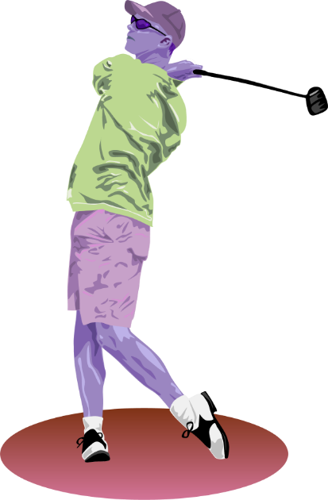
MENU INCLUDES
Two entrees
Toss and Caesar Salad
Two Vegetables
Rolls & Butter
Coffee/Tea & Fountain Drinks

GOLF TOURNAMENT & DINNER: $100 per player
DINNER ONLY: $35 per guest

To reserve your tickets, or for more information
Ed Sigismondi
Call (856)227-1338
e-mail IUAgolf@aol.com

MAKE CHECK PAYABLE TO: Independent Umpire Association IUA
MAIL TO: Fred Fortier
2826 Centre St
Pennsauken, New Jersey 08109
- ------------------------------------------------------------------------------------------------------------------------------------------
- Please fill out and detach this form (Circle Golfer or Dinner Guest)
Golfer or Dinner Guest 1 ________________________ Phone # _______________ Cost $_______
Golfer or Dinner Guest 2 ________________________ Phone # _______________ Cost $_______
Golfer or Dinner Guest 3 ________________________ Phone # _______________ Cost $_______
Golfer or Dinner Guest 4 ________________________ Phone # _______________ Cost $_______
Golfer or Dinner Guest 5 ________________________ Phone # _______________ Cost $_______
Golfer or Dinner Guest 6 ________________________ Phone # _______________ Cost $_______
Golfer or Dinner Guest 7 ________________________ Phone # _______________ Cost $_______
Golfer or Dinner Guest 8 ________________________ Phone # _______________ Cost $________ TOTAL PAID $____________
-------------------------------------------------------------------------------------------------------------------------------------------
____ I would like to be a Hole Sponsor for $100.
____ I would like to be a Prize Hole Sponsor for $150.

Company Name: ____________________________________ Phone # ___________________
Contact: ______________________________________________
(Please email artwork and payment to IUAgolf@aol.com for hole sponsor sign).

